**PRACTICAL FILE**

**WEB AND OPEN SOURCE (ITC 252)**

**BE(IT) 2nd Semester**



**Submitted to:** **Submitted by:**

**Mr NandKishore** **Pragya Sharma**

**UE228079**

**IT Section-2**

**DEPARTMENT OF INFORMATION TECHNOLOGY**

University Institute of Engineering and Technology

Panjab University, Chandigarh

**INDEX**

|  |  |  |
| --- | --- | --- |
| **Sr.No.** | PROGRAMS | **Date** |
| 1. | *To create a webpage consisting Links, Images, marquee tag; using HTML*. |  |
| 2. | *To create different types of lists in HTML.* |  |
| 3. | *To implement Selectors in CSS.* |  |
| 4. | *To create a Table in HTML.* |  |
| 5. | *To create Time Table in HTML.* |  |
| 6. | *To create a Registration Form using HTML and CSS.* |  |
| 7. | *To create a Form (assigned) using HTML and CSS.* |  |
| 8. | *To create a Calculator using HTML and CSS.* |  |
| 9. | *To create a Prompt Box using JS.* |  |

|  |  |  |
| --- | --- | --- |
| 10. | *To create a list using PHP.* |  |

**PROGRAM-1**

**AIM:** To create a webpage consisting Links, Images, marquee tag; using HTML.

**CODE:**

<! DOCTYPE html>

<html>

<head>

<title>Engineering</title>

<body>

<b><h1 align="center" height="30%">A BRIEF DESCRIPTION ABOUT ENGINNERING COLLEGES AND THEIR COURSE</h1>

<b><h2 align="center" height="50%">Tier 1 Colleges in India</h2>

<img src="https://nitkkr.ac.in/wp-content/uploads/2021/10/NIT-K-4.png"width="50%" height="50%">

<span>

<img src="https://uiet.puchd.ac.in/wp-content/uploads/2018/10/cropped-favicon2.png" width="30%" height="40%">

</span>

<b><h3 align="left" height="50%">COURSES AVAILABLE</h3>

<h4>These colleges provide you the following courses:</h4>

<p>1->BTech

2->MTech

3->MBA

4->BCA

</p>

<b><p align="left" height="50%">BTech</p>

<p>The most demmanding course is BTech.An individual can earn a BTech degree in following branches:

1->CSE 2->IT 3->ECE 4->EEE 5->Mechanical 6->Civil 7->Production </p>

</body>

</head>

</html>

**OUTPUT-1:**



**PROGRAM-2**

**AIM:** To create different types of lists in HTML.

**CODE:**

<!DOCTYPE html>

<html lang="en">

<head>

    <meta charset="UTF-8">

    <meta http-equiv="X-UA-Compatible" content="IE=edge">

    <meta name="viewport" content="width=device-width, initial-scale=1.0">

    <title>TYPES OF LISTS</title>

</head>

<body>

    <h1><b><font size="5%">ORDERED LIST</font></b>:

    <ol type="1"start='1'">

        <li>PHP:</li>

        <li>Javascript</li>

        <li>HTML</li>

        <li>CSS:Cascading Style Sheet</li>

        <li>OOPS</li>

    </ol></h1>

    <hr>

    <h2><b><font size="5%">UNORDERED LIST</font></b>:

        <ul type="disc">

            <li>PHP</li>

            <li>Javascript</li>

            <li>HTML</li>

            <LI>CSS</LI>

            <li>OOPS</li>

        </ul>

    </h2>

    <hr>   <dl> <dt><b><font size="5%">HTML:</font></b>

<dd><font size="3%">HTML stands for Hyper text markup language.</font></dd>

        </dt>

    </dl>

</body>

</html>

**OUTPUT-2:**

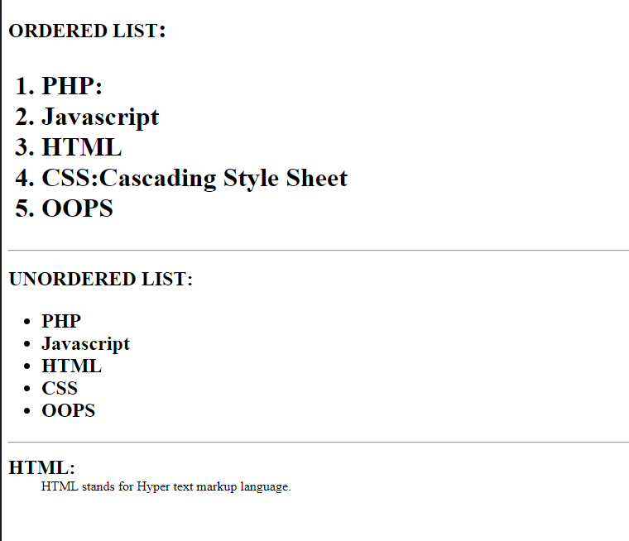

**PROGRAM-3**

**AIM:** To implement Selectors in CSS.

**CODE:**

<!DOCTYPE html>

<html lang="en">

<head>

    <meta charset="UTF-8">

    <meta http-equiv="X-UA-Compatible" content="IE=edge">

    <meta name="viewport" content="width=device-width, initial-scale=1.0">

    <title>Selectors in css</title>

<link rel="stylesheet" href="index.css".css"></head>

<body>

    <span>

    <h1>HTML</h1>

    <p>DHTML</p>

    <div>Javascript</div>

    <h2>PHP</h2>

    </span>

</body>

</html>

**OUTPUT-3:**

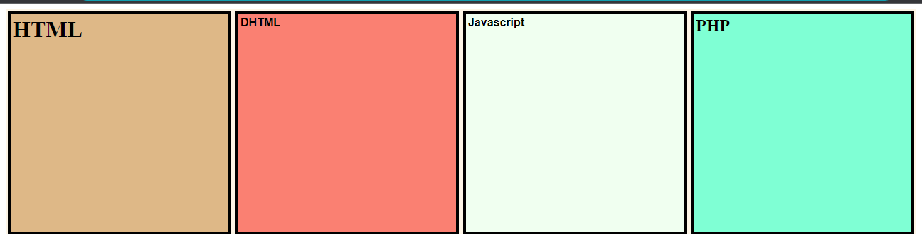

**PROGRAM-4**

**AIM:** To create Table using HTML.

**CODE:**

<!DOCTYPE html>

<html lang="en">

<head>

    <meta charset="UTF-8">

    <meta http-equiv="X-UA-Compatible" content="IE=edge">

    <meta name="viewport" content="width=device-width, initial-scale=1.0">

    <title>Table</title>

</head>

<body>

    <h1 align="center"><b>

            <font size="7%" color="blue">Student Info</font>

        </b></h1>

    <table border="4px solid black" align="center">

        <tr align="center">

            <font size="6%">

                <th><b>Sr.No.</b></th>

                <th><b>Name</b></th>

                <th><b>Roll no.</b></th>

                <th><b>Semester</b></th>

                <th><b>Year</b></th>

            </font>

        <tr>

            <td>1</td>

            <td>Pragya Sharma</td>

            <td>UE228079</td>

            <td>2nd</td>

            <td>2023</td>  </tr>

        <tr>

            <td>2</td>

            <td>Pallavi Kumari</td>

            <td>UE228077</td>

            <td>2nd</td>

            <td>2023</td> </tr>

        <tr>

            <td>3</td>

            <td>Shivangi Vaish</td>

            <td>UE228091</td>

            <td>2nd</td>

            <td>2023</td>

        </tr>  </table>

**OUTPUT-4:**

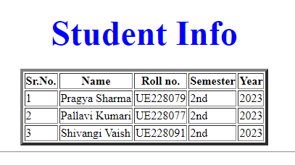

**PROGRAM-5**

**AIM:** To create Time Table using HTML.

**CODE:**

<html>

<head>

<title>Time table of IT Setion-II 2nd sem</title>

</head>

<body>

<h3>Timetable For BE Information Technology (Sec-II) (2nd Semester)</h3>

<table cellpadding=0 cellspacing=0 style="border: thin solid #000000">

<tr align=left>

<th style="border: thin solid #000000">Days</th>

<th width=60 align=center style="border: thin solid #000000">9-10</th>

<th width=60 align=center style="border: thin solid #000000">10-11</th>

<th width=60 align=center style="border: thin solid #000000">11-12</th>

<th width=60 align=center style="border: thin solid #000000">12-13</th>

<th width=60 align=center style="border: thin solid #000000">13-14</th>

<th width=60 align=center style="border: thin solid #000000">14-15</th>

<th width=60 align=center style="border: thin solid #000000">15-16</th>

<th width=60 align=center style="border: thin solid #000000">16-17</th>

</tr>

<tr bgcolor="#EEEEEE" height="45">

<td width="60" style="border: thin solid #000000">Monday</td>

<td height="100%" colspan=1 valign=top align=center style="FONT-SIZE:10px;border: thin solid #000000"><u>Applied Chemistry</u><br>Anil Kumar<br>Room - LH-15 Block-II</td>

<td height="100%" colspan=1 valign=top align=center style="FONT-SIZE:10px;border: thin solid #000000"><u>Differential Equation and Transforms</u><br>Kalpana Dahiya<br>Room - LH-15 Block-II</td>

<td height="100%" colspan=1 valign=top align=center style="FONT-SIZE:10px;border: thin solid #000000"><u>Basic Information Theory and Communication</u><br>Shewangi<br>Room - LH-15 Block-II</td>

<td height="100%" colspan=1 valign=top  style="border: thin solid #000000"></td>

<td height="100%" colspan=2 valign=top  style="border: thin solid #000000"><table width="100%" border="0" height="100%"   cellpadding=0 cellspacing=0 >

<tr><td height=100% width=110 colspan=2 align=center style="FONT-SIZE:10px;border: thin solid #000000"><u>Professional Communication (P)

</u><br>Group 1<br>Room - 409 Block-II</td></tr>

<tr><td height=100% width=110 colspan=2 align=center style="FONT-SIZE:10px;border: thin solid #000000"><u>Basic Information Theory and Communication (P)

</u><br>Group 2<br>Shewangi<br>Room - IT Lab 412 Block-I</td></tr>

<tr><td height=100% width=110 colspan=2 align=center style="FONT-SIZE:10px;border: thin solid #000000"><u>Object Oriented Programming (P)

</u><br>Group 3<br>Nandkishore<br>Room - IT Lab 321 Block-I</td></tr></table></td>

<td height="100%" colspan=2 valign=top style="border: thin solid #000000"><table width="100%" border="0" height="100%"   cellpadding=0 cellspacing=0 >

<tr><td height=13 width=55 colspan=1 valign=top style="border: thin solid #000000"></td><td valign=top height=13 width=55 colspan=1 style="border: thin solid #000000"></td></tr>

<tr><td height=100% width=55 colspan=1 align=center style="FONT-SIZE:10px;border: thin solid #000000"><u>Differential Equation and Transforms

</u><br>Group 2<br>Kalpana Dahiya<br>Room - 308 Block-II</td><td valign=top height=100% width=55 colspan=1 style="border: thin solid #000000"></td></tr>

<tr><td height=100% width=110 colspan=2 align=center style="FONT-SIZE:10px;border: thin solid #000000"><u>Web and Open Source Technologies (P)

</u><br>Group 3<br>Nandkishore<br>Room - IT Lab 321 Block-I</td></tr></table></td>

</tr>

<tr height="45">

<td width="60" style="border: thin solid #000000">Tuesday</td>

<td height="100%" colspan=1 valign=top align=center style="FONT-SIZE:10px;border: thin solid #000000"><u>Applied Chemistry</u><br>Anil Kumar<br>Room - LH-15 Block-II</td>

<td height="100%" colspan=1 valign=top align=center style="FONT-SIZE:10px;border: thin solid #000000"><u>Differential Equation and Transforms</u><br>Kalpana Dahiya<br>Room - LH-15 Block-II</td>

<td height="100%" colspan=1 valign=top align=center style="FONT-SIZE:10px;border: thin solid #000000"><u>Object Oriented Programming</u><br>Ritika(IT)<br>Room - LH-15 Block-II</td>

<td height="100%" colspan=1 valign=top  style="border: thin solid #000000"></td>

<td height="100%" colspan=4 valign=top  style="border: thin solid #000000"><table width="100%" border="0" height="100%"   cellpadding=0 cellspacing=0 >

<tr><td height=100% width=25% colspan=1 align=center style="FONT-SIZE:10px;border: thin solid #000000"><u>Differential Equation and Transforms</u>

<br>Group 1<br>Room - 308 Block-II</td>

<td height=100% width=110 colspan=3 align=center style="FONT-SIZE:10px;border: thin solid #000000"><u>Applied Chemistry (P)</u>

<br>Group 1<br>Renu Thappar<br>Room - Chem Lab-I 106 Block II</td></tr>

<tr><td height=100% width=50% colspan=2 align=center style="FONT-SIZE:10px;border: thin solid #000000"><u>Web and Open Source Technologies (P)</u>

<br>Group 2<br>Nandkishore<br>Room - IT Lab 321 Block-I</td>

<td height=100% width=110 colspan=2 align=center style="FONT-SIZE:10px;border: thin solid #000000"><u>Object Oriented Programming (P)</u>

<br>Group 2<br>Ritika(IT)<br>Room - IT Lab 321 Block-I</td></tr>

<tr><td height=13 width=110 colspan=1 align=center style="FONT-SIZE:10px;border: thin solid #000000"></td>

<td height=13 width=110 colspan=1 align=center style="FONT-SIZE:10px;border: thin solid #000000"></td>

<td height=13 width=110 colspan=1 align=center style="FONT-SIZE:10px;border: thin solid #000000"></td>

<td height=13 width=110 colspan=1 align=center style="FONT-SIZE:10px;border: thin solid #000000"></td>

</tr></table>

</tr>

<tr bgcolor="#EEEEEE" height="45">

<td width="60" style="border: thin solid #000000">Wednesday</td>

<td height="100%" colspan=4 valign=top  style="border: thin solid #000000"><table width="100%" border="0" height="100%"   cellpadding=0 cellspacing=0 >

<tr><td height=100% width=50% colspan=2 align=center style="FONT-SIZE:10px;border: thin solid #000000"><u>Object Oriented Programming (P)</u>

<br>Group 2<br>Ritika(IT)<br>Room - IT Lab 321 Block-I</td>

<td height=100% width=110 colspan=2 align=center style="FONT-SIZE:10px;border: thin solid #000000"><u>Web and Open Source Technologies (P)</u>

<br>Group 2<br>Nandkishore<br>Room - IT Lab 321 Block-I</td></tr>

<tr><td height=100% width=110 colspan=1 align=center style="FONT-SIZE:10px;border: thin solid #000000"></td>

<td height=100% width=110 colspan=3 align=center style="FONT-SIZE:10px;border: thin solid #000000"><u>Applied Chemistry (P)</u>

<br>Group 2<br>Anil Kumar<br>Room - Chem Lab-II 106 Block II</td></tr>

<tr><td height=100% width=110 colspan=1 align=center style="FONT-SIZE:10px;border: thin solid #000000"></td>

<td height=100% width=110 colspan=1 align=center style="FONT-SIZE:10px;border: thin solid #000000"></td>

<td height=100% width=110 colspan=1 align=center style="FONT-SIZE:10px;border: thin solid #000000"><u>Basic Information Theory and Communication (P)</u>

<br>Group 3<br>Shewangi<br>Room - IT Lab 412 Block I</td></tr></table>

<td height="100%" colspan=1 valign=top  style="border: thin solid #000000"></td>

<td height="100%" colspan=1 valign=top align=center style="FONT-SIZE:10px;border: thin solid #000000"><u>Basic Information Theory and Communication</u><br>Shewangi<br>Room - LH-15 Block-II</td>

<td height="100%" colspan=2 valign=top  style="border: thin solid #000000"><table width="100%" border="0" height="100%"   cellpadding=0 cellspacing=0 >

<tr><td height=13 width=110 colspan=1 align=center style="FONT-SIZE:10px;border: thin solid #000000"></td>

<td height=13 width=110 colspan=1 align=center style="FONT-SIZE:10px;border: thin solid #000000"></td></tr>

<tr><td height=100% width=110 colspan=2 align=center style="FONT-SIZE:10px;border: thin solid #000000"><u>Professional Communication (P)

</u><br>Group 2<br>Room - 409 Block-II</td></tr>

<tr><td height=100% width=110 colspan=2 align=center style="FONT-SIZE:10px;border: thin solid #000000"><u>Object Oriented Programming (P)

</u><br>Group 3<br>Nandkishore<br>Room - IT Lab 321 Block-I</td></tr></table></td>

</tr>

<tr height="45">

<td width="60" style="border: thin solid #000000">Thursday</td>

<td height="100%" colspan=1 valign=top align=center style="FONT-SIZE:10px;border: thin solid #000000"><u>Object Oriented Programming</u><br>Ritika(IT)<br>Room - LH-15 Block-II</td>

<td height="100%" colspan=1 valign=top align=center style="FONT-SIZE:10px;border: thin solid #000000"><u>Differential Equation and Transforms</u><br>Kalpana Dahiya<br>Room - LH-15 Block-II</td>

<td height="100%" colspan=1 valign=top align=center style="FONT-SIZE:10px;border: thin solid #000000"><u>Applied Chemistry</u><br>Anil Kumar<br>Room - LH-15 Block-II</td>

<td height="100%" colspan=1 valign=top  style="border: thin solid #000000"></td>

<td height="100%" colspan=2 valign=top  style="border: thin solid #000000"><table width="100%" border="0" height="100%"   cellpadding=0 cellspacing=0 >

<tr><td height=100% width=110 colspan=2 align=center style="FONT-SIZE:10px;border: thin solid #000000"><u>Basic Information Theory and Communication (P)

</u><br>Group 1<br>Shewangi<br>Room - IT Lab 412 Block-I</td></tr>

<tr><td height=100% width=110 colspan=2 align=center style="FONT-SIZE:10px;border: thin solid #000000"><u>Object Oriented Programming (P)</u>

<br>Group 2<br>Ritika(IT)<br>Room - IT Lab 321 Block-I</td></tr>

<tr><td height=100% width=110 colspan=2 align=center style="FONT-SIZE:10px;border: thin solid #000000"><u>Professional Communication (P)

</u><br>Group 3<br>Room - 409 Block-II</td></tr></table></td>

<td height="100%" colspan=1 valign=top align=center style="FONT-SIZE:10px;border: thin solid #000000"><u>Professional Communication</u><br>Room - LH-15 Block-II</td>

<td height="100%" colspan=1 valign=top  style="border: thin solid #000000"><table width="100%" border="0" height="100%"   cellpadding=0 cellspacing=0 >

<tr><td height=13 width=110 colspan=1 align=center style="FONT-SIZE:10px;border: thin solid #000000"></td></tr>

<tr><td height=13 width=110 colspan=1 align=center style="FONT-SIZE:10px;border: thin solid #000000"></td></tr>

<tr><td height=100% valign=top align="center" style="FONT-SIZE:10px;border: thin solid #000000"><u>Differential Equations and Transforms</u><br>Group 3<br>Kalpana Dahiya<br>Room - 308 Block II </td></tr>

</table></td>

</tr>

<tr bgcolor="#EEEEEE" height="45">

<td width="60" style="border: thin solid #000000">Friday</td>

<td height="100%" colspan=3 valign=top  style="border: thin solid #000000"><table width="100%" border="0" height="100%"   cellpadding=0 cellspacing=0 >

<tr><td height=100% width=66% colspan=2 align=center style="FONT-SIZE:10px;border: thin solid #000000"><u>Object Oriented Programming (P)</u>

<br>Group 1<br>Ritika(IT)<br>Room - IT Lab 321 Block-I</td>

<td height=13 width=110 colspan=1 align=center style="FONT-SIZE:10px;border: thin solid #000000"></td></tr>

<tr><td height=13 width=110 colspan=1 align=center style="FONT-SIZE:10px;border: thin solid #000000"></td>

<td height=13 width=110 colspan=1 align=center style="FONT-SIZE:10px;border: thin solid #000000"></td>

<td height=13 width=110 colspan=1 align=center style="FONT-SIZE:10px;border: thin solid #000000"></td></tr>

<tr><td height=100% width=110 colspan=3 align=center style="FONT-SIZE:10px;border: thin solid #000000"><u>Applied Chemistry (P)</u>

<br>Group 2<br>Anil Kumar<br>Room - Chem Lab-II 106 Block II</td></tr></table></td>

<td height="100%" colspan=1 valign=top align=center style="FONT-SIZE:10px;border: thin solid #000000"><u>Differential Equation and Transforms</u><br>Kalpana Dahiya<br>Room - LH-15 Block-II</td>

<td height="100%" colspan=1 valign=top  style="border: thin solid #000000"></td>

<td height="100%" colspan=1 valign=top align=center style="FONT-SIZE:10px;border: thin solid #000000"><u>Applied Chemistry</u><br>Anil Kumar<br>Room - LH-15 Block-II</td>

<td height="100%" colspan=1 valign=top align=center style="FONT-SIZE:10px;border: thin solid #000000"><u>Object Oriented Programming</u><br>Ritika(IT)<br>Room - LH-15 Block-II</td>

<td height="100%" colspan=1 valign=top align=center style="FONT-SIZE:10px;border: thin solid #000000"><u>Professional Communication</u><br>Room - LH-15 Block-II</td> </tr>

</body></html>

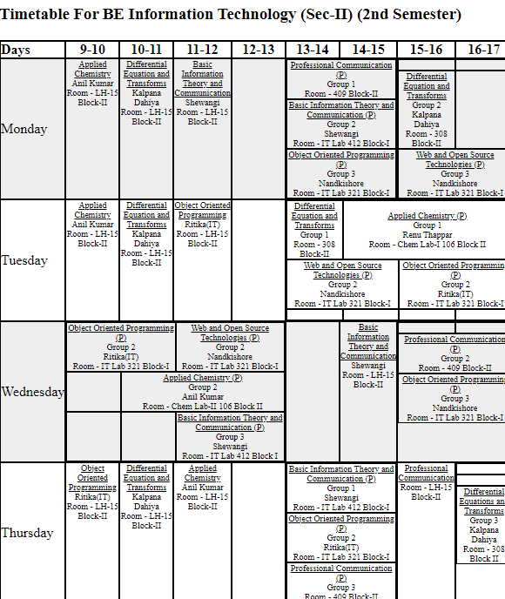

**PROGRAM-6**

**AIM:** To create a Registration Form using HTML and CSS.

**CODE:**

<!DOCTYPE html>

<html lang="en">

    <head>

    <meta charset="UTF-8">

    <meta http-equiv="X-UA-Compatible"content="IE=edge">

    <meta name="viewport"content="width=device-width,initial-scale=1.0">

    <title>Webpage</title>

    <style>

        body{

            background-color: bisque;

        }

        h1{

            font-size: xx-large;

            color: white;

            display: block;

            background-color: black;

            border: 2px solid white;

            border-radius: 10px;

            box-shadow: 10px 13px 20px 10px silver;

              }

        div{

            font-size: large;

            font-weight: bolder;

            font-family:cursive;}

        span:hover{

            cursor: pointer;

            color: blue;

        }

        div input{

            width: 200px;

            padding: 7px 12px;

            border: 2px solid black;

        }

        label{

            font-size: large;

            font-family: cursive;

            font-weight: bolder;

        }

    </style>

    <body>

        <h1><marquee behavior="alternate" direction="right" scrollamount="7" hspace="300px">Registration Form</marquee></h1>

        <form action="fullstack.html">

            <div>

                Name:<input type="text" placeholder="Your name">

            </div>

            <br>

                <div>Father's Name:<input type="text" placeholder="Father's name"></div>

                <br>

            <div>

                Roll no:<input type="number"placeholder="Your roll no (in digits)">

            </div>

            <br>

            <div>Address:<input type="text" placeholder="Your permanent address"></div><br>

            <div>

                Branch:<input type="text"placeholder="Your branch">

            </div>

            <br>

            <div>

                Year:<input type="number"placeholder="e.g 20XX">

            </div>

            <br>

            <div>D.O.B.<input type="date"></div><br>

            <div>Gender:Male <input type="radio"> Female <input type="radio"></div><br>

            <div>18+ or above:<input type="checkbox"></div><br>

            <div>Course:CSE<input type="checkbox">CSE<input type="checkbox">IT<input type="checkbox">ECE<input type="checkbox">EEE<input type="checkbox"></div><br>

            <label for="learning">Area of Interest:</label>

            <select name="" id="">

                <option value="Frontend">Frontend</option>

                <option value="Backend">Backend</option>

                <option value="Machine learing">Machine learning</option>

                <option value="AI">AI</option>

            </select>

            <br>

            <hr>

            <!-- <div>Describe yourself in one line:<figcaption><input type="text"></figcaption></div> -->

           <span> <div><b><input type="submit" value="submit"><input type="reset" value="reset"></b></div><br></span>

        </form>

    </body>

    </head>

</html>

**OUTPUT-6:**

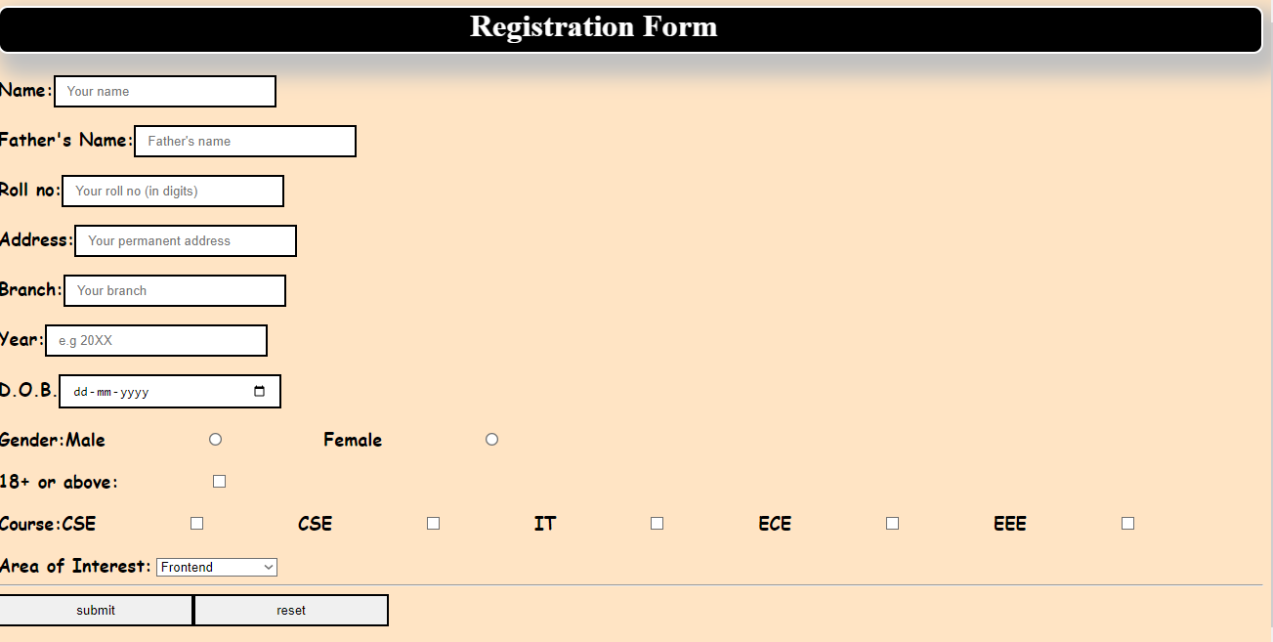

**PROGRAM-7**

**AIM:** To create a Form (assigned) using HTML and CSS.

**CODE:**

<!DOCTYPE html>

<html lang="en">

<head>

    <meta charset="UTF-8">

    <meta http-equiv="X-UA-Compatible" content="IE=edge">

    <meta name="viewport" content="width=device-width, initial-scale=1.0">

    <title>Form</title>

    <style>

        input{

            padding: 3px;

            border: 2px solid black;

            box-shadow: 5px 5px 5px rgb(26, 25, 25);

            margin: 0px 20px;

        }

        body{

            background-color: black;

            /* display: inline-block;

            width: 100px;

            height: 100px; */

        }

        div{

            /* align-items: center;

            justify-content: center; */

            color: white;

            padding: 6px;

            font-weight: bolder;

            display: flex;

            font-family: sans-serif;

            /* box-shadow: 5px 5px 2px white; */

        }

        div table{

            margin: 0px 12px;

        }

        div table tr td{

            padding: 6px;

            margin: 7px;

        }

        div table tr td input{

            background-color: silver;

        }

        span{

            background-color: aquamarine;

        }

        span:hover{

            cursor: pointer;

            color: aquamarine;

        }

    </style>

</head>

<body>

    <div>

        FIRST NAME <input type="text" maxlength="30" placeholder="max 30 characters a-z and A-Z">

    </div>

    <div>LAST NAME <input type="text"></div>

    <div>DATE OF BIRTH <input type="date" placeholder="date"><input type="month" > <input type="number" placeholder="year"></div>

    <div>EMAIL ID <input type="email"></div>

    <div>MOBILE NUMBER <input type="tel" placeholder="10 digit number" maxlength="10"></div>

    <div>GENDER &nbsp;MALE <input type="radio"> FEMALE <input type="radio"></div>

    <div >ADDRESS <input id="address" type="text" ></div>

    <div>CITY <input type="text"></div>

    <div>PINCODE <input type="number" placeholder="6 digit number" maxlength="6"></div>

    <div>STATE <input type="text"></div>

    <div>COUNTRY <input type="text" placeholder="India"></div>

    <div>HOBBIES &nbsp;

        Reading<input type="checkbox"> Watching movies<input type="checkbox"> Listening Music<input type="checkbox">Coding<input type="checkbox">Others<input type="checkbox">

    <input type="text">

    </div>

    <div>Qualifications

        <div>

        <table >

            <tr>

                <th>Sr.No</th>

                <th>Examination</th>

                <th>Board</th>

                <th>Percentage</th>

                <th>Year of Passing</th>

            </tr>

            <tr>

                <td>Class X</td>

                <td><input type="text"></td>

                <td><input type="text"></td>

                <td><input type="text"></td>

                <td><input type="text"></td>

            </tr>

            <tr>

                <td>Class XII</td>

                <td><input type="text"></td>

                <td><input type="text"></td>

                <td><input type="text"></td>

                <td><input type="text"></td>

            </tr>

            <tr>

                <td>Graduation</td>

                <td><input type="text"></td>

                <td><input type="text"></td>

                <td><input type="text"></td>

                <td><input type="text"></td>

            </tr>

            <tr>

                <td>Masters</td>

                <td><input type="text"></td>

                <td><input type="text"></td>

                <td><input type="text"></td>

                <td><input type="text"></td>

            </tr>

        </table>

        </div>

    </div>

    <div>COURSES APPLIED FOR &nbsp;

        B Tech<input type="radio">M Tech<input type="radio">MS<input type="radio">MBA<input type="radio">

    </div>

    <hr>

    <span> <div><b><input type="submit" value="submit"><input type="reset" value="reset"></b></div><br></span>

</body>

</html>

**OUTPUT-7:**

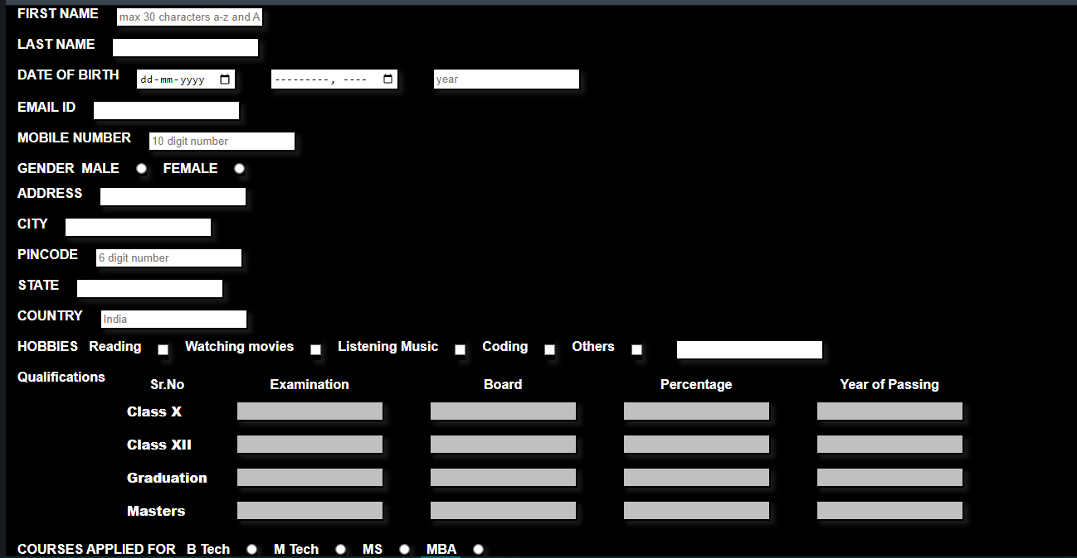

**PROGRAM-8**

**AIM:** To create a calculator using HTML and CSS.

**CODE:**

<!DOCTYPE html>

<head>

<title> Calculator </title>

<style>

h1 {

text-align: center;

padding: 23px;

background-color: rgb(100, 278, 112);

}

#clear{

width: 132px;

border: 3px solid gray;

border-radius: 3px;

padding: 20px;

background-color: lightgrey;

}

.formstyle

{

width: 300px;

height: 530px;

margin: auto;

border: 3px solid black;

border-radius: 5px;

padding: 20px;

}

input

{

width: 20px;

background-color:lightgray ;

color: black;

border: 3px solid gray;

border-radius: 5px;

padding: 26px;

margin: 5px;

font-size: 15px;

}

#calc{

width: 240px;

border: 5px solid black;

border-radius: 3px;

padding: 20px;

margin: auto;

}

</style>

</head>

<body>

<h1> CALCULATOR </h1>

<div class= "formstyle">

<form name = "form1">

<!-- This input box shows the button pressed by the user in calculator. -->

<input id = "calc" type ="text" name = "answer"><br><br>

<!-- Display the calculator button on the screen. -->

<!-- onclick() function display the number passed by the user. -->

<input type = "button" value = "1" onclick = "form1.answer.value += '1' ">

<input type = "button" value = "2" onclick = "form1.answer.value += '2' ">

<input type = "button" value = "3" onclick = "form1.answer.value += '3' ">

<input type = "button" value = "+" onclick = "form1.answer.value += '+' ">

<br><br>

<input type = "button" value = "4" onclick = "form1.answer.value += '4' ">

<input type = "button" value = "5" onclick = "form1.answer.value += '5' ">

<input type = "button" value = "6" onclick = "form1.answer.value += '6' ">

<input type = "button" value = "-" onclick = "form1.answer.value += '-' ">

<br><br>

<input type = "button" value = "7" onclick = "form1.answer.value += '7' ">

<input type = "button" value = "8" onclick = "form1.answer.value += '8' ">

<input type = "button" value = "9" onclick = "form1.answer.value += '9' ">

<input type = "button" value = "*" onclick = "form1.answer.value += '*' ">

<br><br>

<input type = "button" value = "=" onclick = "form1.answer.value = eval(form1.answer.value) ">

<input type = "button" value = "0" onclick = "form1.answer.value += '0' ">

<input type = "button" value = "." onclick = "form1.answer.value += '.' ">

<input type = "button" value = "/" onclick = "form1.answer.value += '/' ">

<br>

<!-- Display the Cancel button and erase all data entered by the user. -->

<input type = "button" id= "clear" value = "AC" onclick = "form1.answer.value = ' ' " >

<input type = "button" id= "clear" value = "Del" onclick = "form1.answer.value=form1.answer.value.slice(0,-1)" >

<br>

</form></div>

</body>

</html>

**OUTPUT-8:**

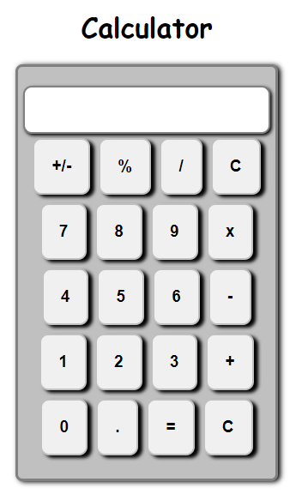

**PROGRAM-9**

**AIM:** To create a prompt box using Javascript.

**CODE:**

<!DOCTYPE html>

<html lang="en">

<head>

    <meta charset="UTF-8">

    <meta http-equiv="X-UA-Compatible" content="IE=edge">

    <meta name="viewport" content="width=device-width, initial-scale=1.0">

    <title>Document</title>

</head>

<body>

    <script>

        var a=prompt(alert("Hello Pragya!Welcome to Prompt box"));

        document.write(a)

        alert("Prompt box says hello!!");

        confirm("do you want to continue?");

    </script>

</body>

</html>

**OUTPUT-9:**

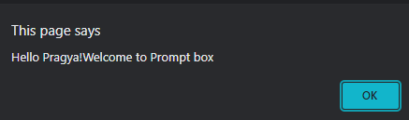

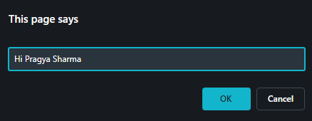

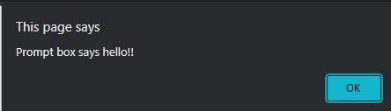

**PROGRAM-10**

**AIM:** To create a list using PHP.

**CODE:**

<?php

$tvd = array("Stefan","Elena","Damon");

list($x, $y, $z) = $tvd;

echo "Salvatore Brothers: $x and $z.";

?>

**OUTPUT-10:**

